**Microprocessor Lab**

Laboratory Activity No. 1

**Familiarization with TinkerCAD**

|  |
| --- |
|  |

Score

*Submitted by:*

**Lapid, Henderson Eiann C.**

**Saturday – 1:00 pm – 4:00 pm / Section | Block 2**

*Date Submitted*

**16-09-2023**

*Submitted to:*

**Engr. Maria Rizette H. Sayo**

1. Exercise

a. A process in Tinkercad where we can develop electronic circuits that can be quickly updated, modified and tested is called **PROTOTYPING**.

b. In Tinkercad, **SIMULATION** tests the working of the circuits and the components.

c. The device used to assemble and connect the various components is known as **BREADBOARD**.

d. In an electronic circuit with LED, the positive end of the circuit should be connected to

**ANODE** and negative end should be connected to **CATHODE** the LED.

e. A **RESISTOR** is used to restrict the flow of current to electrical components.

2. Label the following:

1. Anode and Cathode in a LED

Cathode (-)

Anode (+)

1. Different parts of breadboard

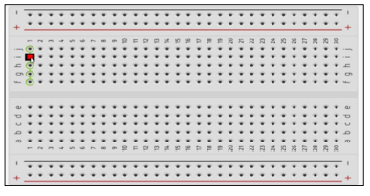

Edge

Main Area

Edge

Main Area – strips and holes to insert and connect electronic components together.

Edge – Power rails, connect GND (ground) to the negative (-) rail, then the positive end of a power source to the positive (+) rail.

1. List the electronic components used in a circuit assembly.

Basic Electronic Components

|  |  |
| --- | --- |
| **Electronic Component** | **Function** |
| **LED**  5mm LED | Light-emitting diode or LED emits light when current flows through it, as an indicator of a working circuit or simply its function to emit and shed light. |
| **Resistor**  Resistors | Resistors resist the flow of electrical current, limiting the current flow as a means of control or regulation. |

|  |  |
| --- | --- |
| **Power Source**  Duracell Duralock 9.0V Alkaline Battery (MN1604) - Made in Malaysia - Uncarded Bulk | Supplies power to the assembled circuit. Power could be AC (alternating current) or DC (direct current). DC voltage source supplies constant voltage output to circuits, while an AC power source supplies varying or fluctuating current continuously over time. |
| **Capacitor**  50pcs 16V 1000uF 16V Nichicon VK 10x13 small size Electrolytic Capacitor | eBay | Capacitors are able to store electrical charges, depending on the size of the capacitor, the amount of electrical charges that can be stored and dissipated varies. |
| **Transistor**  Transistor - Mosfet BS170, Small Signal | Antique Electronic Supply | A transistor is a semiconductor electronic component with three terminals, a transistor can either act as an amplifier or as a switch. |